Title of the Project: Automatic Gate Opener
Group Information
Name
Atharva goswami 23070123057
Jeet bisht 23070123068
Akarsh khot 23070123012

1. Working of Project

Project: Arduino Automatic Gate Opener
This project uses an Arduino to create a model automatic gate. An ultrasonic sensor detects an approaching object and signals a servo motor to open the gate arm, closing it again once the object moves away.

How It Works
- Sense: The HC-SR04 ultrasonic sensor constantly measures the distance to the nearest object.
- Decide: The Arduino checks if the measured distance is less than a set threshold (e.g., 10 cm).
- Act: If the threshold is crossed, the servo motor rotates to open the gate. Otherwise, it moves to the closed position.

Tech Stack & Tools
- Hardware: Arduino Uno, HC-SR04 Ultrasonic Sensor, SG90 Servo Motor.
- Software: Arduino IDE, using C++ with the standard Servo.h library.

Execution and Output
- Physical Output: The servo arm (gate) moves up when an object is close and moves down when the object is gone.
- Serial Output: The Arduino IDE's Serial Monitor displays a live feed of the distance measurements for monitoring and debugging.

How to Run
- Assemble Circuit: Connect the sensor and servo to the correct Arduino pins as defined in the code (Pins 11, 12, 13).
- Upload Code: Open the code in the Arduino IDE, select your board and port, and click "Upload".
- Test: Power the Arduino and move your hand toward the sensor to test the gate's operation.

Execution Screenshots
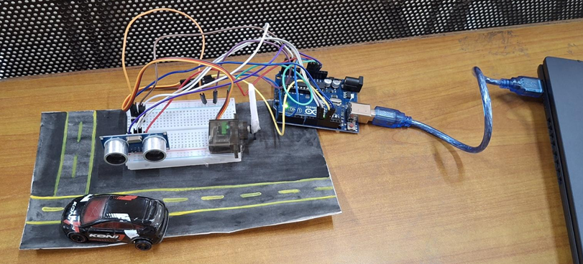
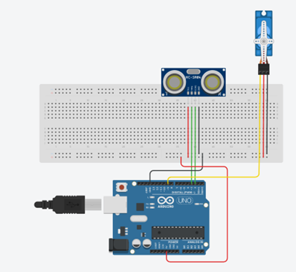

2. Innovation / Novelty / Contribution

Unique Feature or Enhancement:
Enhance the gate opener by adding red and green LEDs as status indicators. The green light can signal when the gate is open, and the red light can signal when it's closed, providing clear visual feedback.

- Student’s Individual Contribution: Each Students Contribution Link
- Table Format (recommended for clarity):
Student Name | Role/Contribution | GitHub Profile | Key Commits / Pull Requests
Atharva | Frontend Design, README | https://github.com/Hussain1402 | https://github.com/SohamJade/Automatic-Gate-opener/commits?author=Hussain1402
Jeet | Shell Scripts, Automation | https://github.com/SohamJade | https://github.com/SohamJade/Automatic-Gate-opener/commits?author=SohamJade
Akarsh | Testing, | https://github.com/ombhombe2344 | https://github.com/SohamJade/Automatic-Gate-opener/commits?author=ombhombe2344

Challenges Faced and Solved:

A common challenge is the sensor providing false readings, causing the gate to open randomly. This is solved with a software filter that requires several consecutive "close" readings before opening the gate, which ignores single errors and improves reliability.

4. Pushing the Project to GitHub
- GitHub Repository Link: https://github.com/SohamJade/Automatic-Gate-opener
- README File: It contains all the necessary information related to the project repository which explains the objective and working of the project. It helps users understand the reason and operation of the given project.

